**Pneumonia Detection Using**

**Convolutional Neural Networks (CNNs)**

Dr. P. Josephin Shermila 1

Associate professor

Department of Artificial Intelligence

and Data Science

R.M.K College of Engineering and

Technology, Chennai, India.

[blossomshermi@gmail.com](mailto:blossomshermi@gmail.com)

Akila. M 3

Department of Artificial Intelligence

and Data Science

R.M.K College of Engineering and

Technology, Chennai, India.

[akil20ad003@rmkcet.ac.in](mailto:akil20ad003@rmkcet.ac.in)

**ABSTRACT:** Pneumonia is an infection that inflames the air sacs in one or both lungs. It makes the lungs' air sacs, or alveoli, swell with fluid or pus. Pneumonia may be caused by bacteria, viruses, or fungi. An estimated 450 million individuals worldwide contract pneumonia every year, making it one of the most common respiratory infections.

Mild to severe symptoms might range from having a cough that produces mucus (a sticky substance), to having a fever, chills, and difficulty breathing. Your age, general health, and the cause of your illness all affect how serious your case of pneumonia is.

During 2020, COVID pandemic, pneumonia had been a life-threatening disease. Many people have expired during the COVID crisis. However, 50% of the people full of COVID were recovered by medication. On the opposite hand people faced with pneumonia, if tormented by COVID -19

hopelessly lost their lives. The patients littered with pneumonia were 54.64%

Abirami. S 2

Department of Artificial Intelligence

and Data Science

R.M.K College of Engineering and

Technology, Chennai, India.

[abir20ad001@rmkcet.ac.in](mailto:abir20ad001@rmkcet.ac.in)

Alapati Devi Anusha 4

Department of Artificial Intelligence

and Data Science

R.M.K College of Engineering and

Technology, Chennai, India.

[alap20ad004@rmkcet.ac.in](mailto:alap20ad004@rmkcet.ac.in)

among severe COVID-19 cases and 5% among mild to moderate COVID-19 cases.

In our project, we require the proper x-ray image of the patient. We prefer x-ray since it's affordable for people too. X-ray is cost-efficient in comparison to CT-SCAN.

1. **INTRODUCTION**

Pneumonia can cause the air sacs to swell with fluid or pus (purulent material), which can lead to a cough that produces pus or phlegm, a fever, chills, and breathing difficulties. Pneumonia can be brought on by several different species, including bacteria, viruses, and fungi. The severity of pneumonia can range from minor to life-threatening. The most vulnerable groups include newborns and young children, adults over 65, and those with health conditions or weaker immune systems.

Pneumonia can be brought on by numerous bacteria. In the air we breathe, bacteria and viruses are the most prevalent. Usually, your body protects you from harmful bacteria getting into your lungs. But even if your health is normally strong, these viruses occasionally have the capacity to overwhelm your immune system.

During the pandemic, doctors were of a good scarcity and it had been time-consuming for them to treat the deadly disease together with checking each patient's reports.

On our website, you'll be able to upload the image of the x-ray and it'll display the results whether you are affected with Pneumonia or not. Our motive is to classify pneumonia which is caused by a scourge or bacteria. To train our model by Convolution neural network process, we've taken the info set i.e, the X-RAY images from a government hospital. The data set consists of 1200 images. The accuracy of the training data is 79% and the test data is 83%.

1. **LITERATURE SURVEY**

CNN is the best algorithm that identifies the important features of the data without any supervision. Where CNN is at its best in terms of its feature extraction from the image, classification of an image, and detection of an object.

According to the order of year of published ,the various CNN architectures which acts as a building block of algorithm are LeNet-5 ,Alex Net ,VGG-16 ,Inception-v1 ,Inception-v3 ,ResNet-50 ,Xception ,Inception-v4 ,Inception-ResNets ,etc,.. However, the pandemic caused by COVID virus leads to a new wave of technological development in the process of detection and diagnosis. Some of the recently developed successful models developed by various authors using CNN are

The author Brunese and others developed a framework of a model with 3 classes by using VGG-16 architecture and Grad-CAM algorithm for detecting pneumonia with an accuracy of 96.2% with the dataset consisting of 6523 chest X-rays(CXR).

Jin et al developed a hybrid SVM classifier model which consists of 3 stages including feature selection, feature extraction, and SVM classifier stage with an accuracy of 98.62% on 1743 CXR.

Rajaraman established a framework that deployed through transfer learning and was involved in ensemble learning. which is trained using 4 public datasets consisting of 16,700 x-rays which yield an accuracy between 94% and 98%.

Jain et al developed a 6 CNN model which has varied parameters, hyper parameters, and convolutional layers. The performance of the model also varied between 70-91% based on the convolution layers used in the model. However, the accuracy has to improve for these models by tuning the parameters.

Al Namlook and others proposed 7 models for detecting pneumonia which consist of CNN, random forest, decision tree, adaptive boosting,k-nearest neighbor, gradient boosting, and XGB boosting. While comparing the accuracy of these models the CNN model exceeds the other model and achieved an accuracy of 98.46%

Some of the models used transfer learning and other architectures however the CNN model provides the best accuracy than that which is used for better classification and detection of pneumonia. Hence in our model, we provided the best solution for the great crisis of the problem pneumonia detection and classification by using the CNN architecture.

1. **EXISTING SYSTEM**

There are some limitations in the existing model that are believed to be important to stay in thought. The primary biggest limitation is that there's no history of the associated patient thought of in the analysis model. Secondly, solely frontal chest X-rays were used however it's been shown that lateral read chest X-rays also are useful in designation. Thirdly, since the model exercises tons of convolutional layers, the model would like high process power otherwise it’ll eat up tons of your time in computations.

1. **PROPOSED SYSTEM**

Our system's motive is to enhance the existing model. The accuracy percentage is increased by training the model with 2000 images datasets. The dataset is collected from hospitals, and by training the model using supervised learning the accuracy has increased a lot.

1. **CNN ARCHITECTURE**

CNN models are feed-forward networks with convolutional layers, pooling layers,ﬂattening layers and absolutely connected layers using appropriate activation functions.

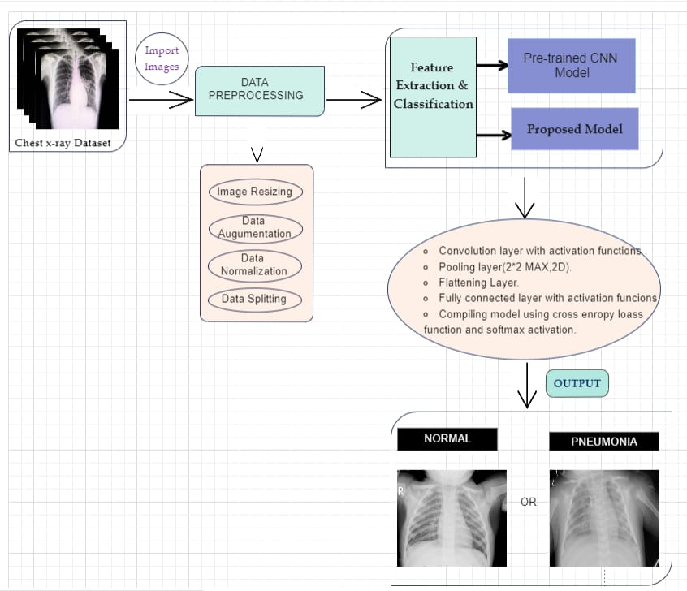

1. **Convolutional layer**

It is the building block of CNNs. Convolution operation is done in arithmetic to merge 2 functions. within the CNN models, the input image is 1st regenerated into matrix kind. Convolution filter is applied to the input

matrix that slides over it, activity element-wise multiplication and storing the sum. This creates a feature map. three × three filter is usually used to form 2nd feature maps once pictures square measure black and white. Convolutions square measure performed in 3D when the input image is depicted as a 3D matrix wherever the RGB color represents the dimension. Many feature detectors square measure operate with the input matrix to generate a layer of feature maps that therefore forms the convolutional layer.

1. **Activation functions**

All four models bestowed during this paper use 2 totally different

activation functions, particularly ReLU activation perform and softmax activation function. The ReLU activation perform stands for corrected linear perform [18]. It is a nonlinear perform that outputs zero once the input is negative and outputs one when the input is positive. The ReLU perform is given by the subsequent formula:

This type of activation perform is generally employed in CNNs because it deals with the problem of vanishing gradients and is helpful for increasing the nonlinearity of layers. ReLU activation perform has several variants like abuzz ReLUs, Leaky ReLUs and constant quantity ReLUs. blessings of ReLU over different activation functions ar computational simplicity and depictive scantness. Softmax activation perform is used altogether four models bestowed during this paper. This generally used activation function is used within the last dense layer of all the four models [19]. This activation function normalizes inputs into a chance distribution. Categorical cross-entropy cost performance is generally used with this kind of activation.

1. **Pooling layer**

Convolutional layers area unit followed by pooling layers. The kind of the Pooling layer employed in all four models is max-pooling layers. The max-pooling layer having a dimension a pair of 2× 2 selects the most constituent intensity values from the window of the image presently lined by the kernel. Max-pooling is employed to down sample pictures, thus reducing the spatiality and quality of the image [20].

Two different varieties of pooling layers may also be used in that area unit general pooling and overlapping pooling. The models conferred during this paper use max-pooling technique as it helps acknowledge salient options within the image.

1. **Flattening layer and fully connected layers**

After the input image passes through the convolutional layer and therefore the pooling layer, it's fed into the flattening layer. This layer flattens out the input image into a column, reducing its computational quality. This is often then fed into the totally connected layer/dense layer.

The totally connected layer has multiple layers, and each node within the 1st layer is connected to each node within the second layer. every layer within the totally connected layer extracts options, and on this basis, the network makes a prediction. This method is understood as forward propagation. once forward propagation, a cost function is calculated. It's a live performance of a neural network model. The cost employed in all four models is categorical cross-entropy. once the value function is calculated, back propagation takes place. This method is continual till the network achieves optimum performance. Adam improvement algorithmic program has been used in all four models.

1. **Reducing overfitting**

The first model exhibits substantial overfitting; therefore, dropout technique was used within the later models .Dropout technique helps to reduce overfitting and tackle the matter of vanishing gradients. Dropout technique encourages every somatic cell to make its own individual illustration of the computer file. This technique on a random basis cuts connections between neurons in ordered layers throughout the coaching method. Learning rate of models was additionally changed, to reduce overfitting. knowledge augmentation technique can even be used to scale back overfitting.

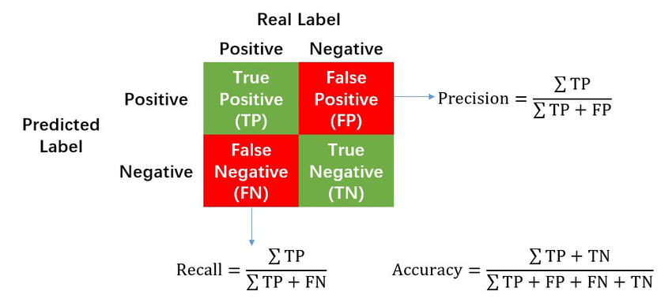

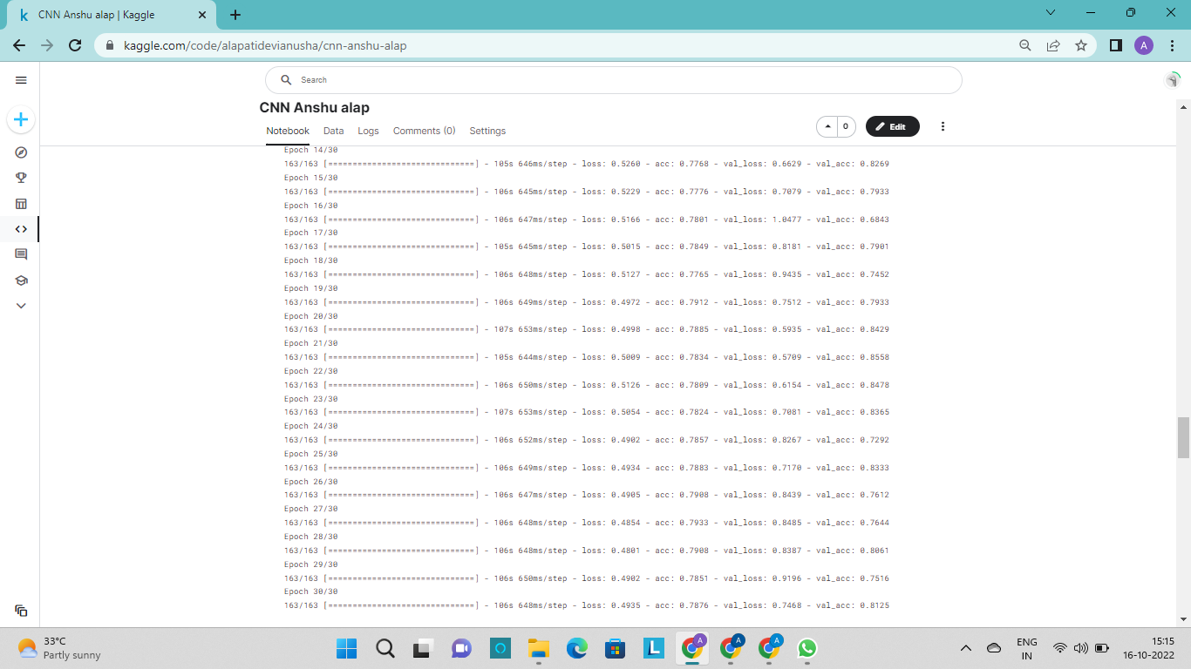

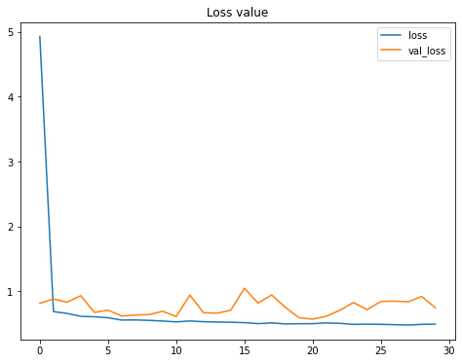

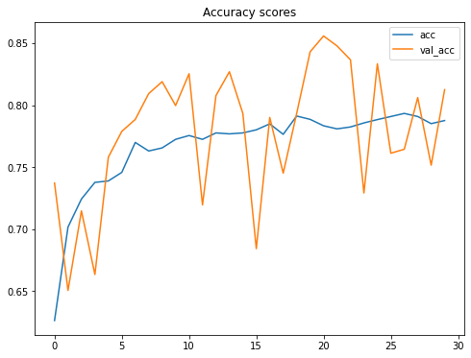

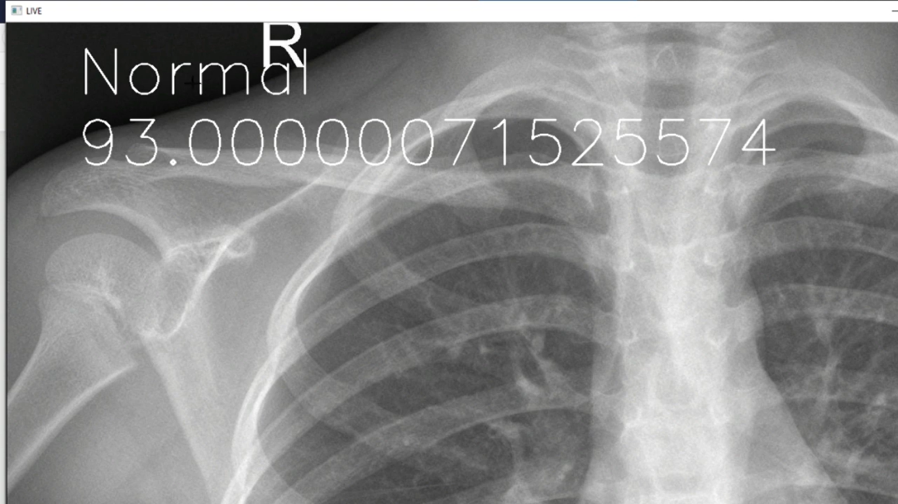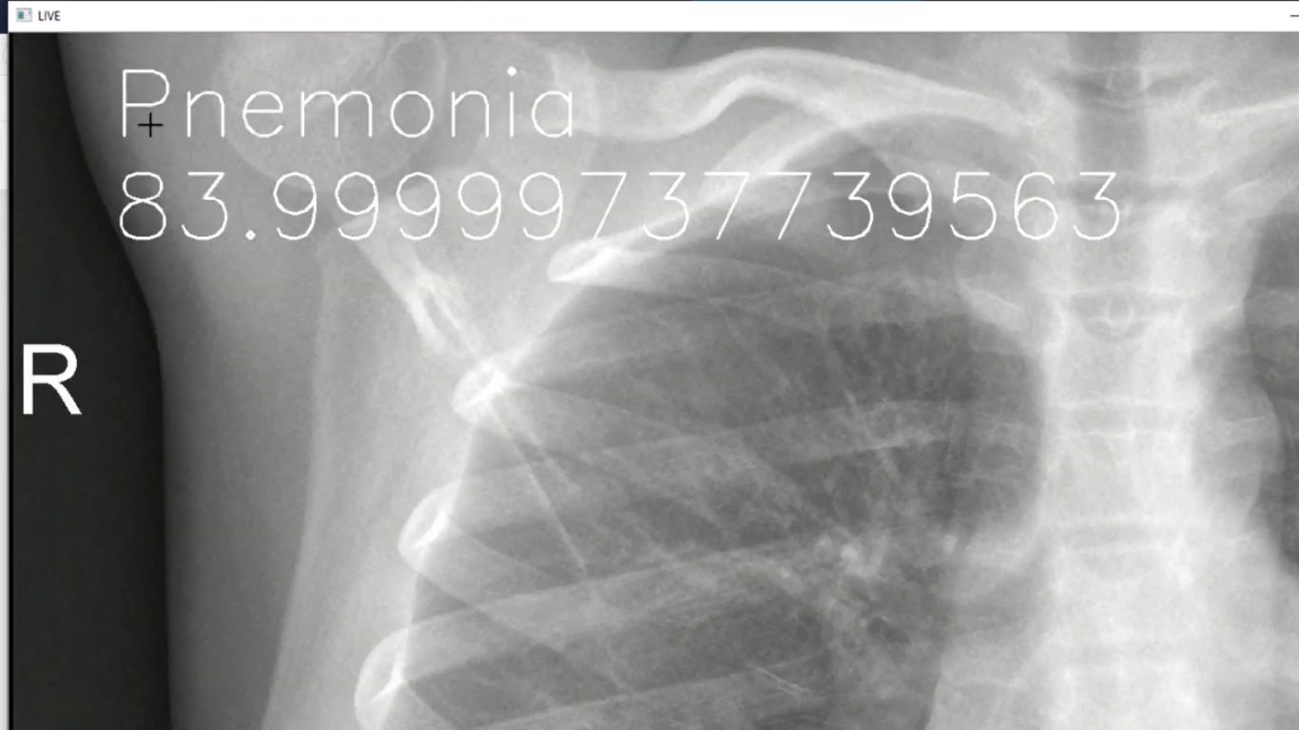

1. **CONCLUSION**

Along with the share affected lungs and accuracy.

Patient no. together with aadhar number needs to be entered.

Priorly, the patient must be registered with our website.

Patient info i.e the anamnesis is stored in a database.

Patient no. together with aadhar number needs to be entered for login.

So, the website would suggest you the medicines for the cure of diseases like doctors.

This brings down the burden put upon doctors.

Patient no. together with aadhar number should be entered.

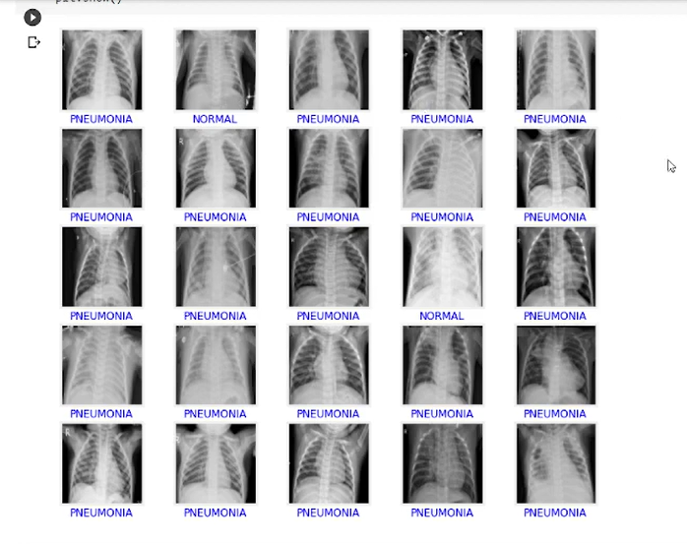

**REFERENCES:**

[1]<https://www.analyticsvidhya.com/blog/2020/09/pneumonia-detection-using-cnn-with-implementation-in-python/>

[2]<https://ieeexplore.ieee.org/document/8869364>

[3]<https://www.researchgate.net/publication/361505948_Pneumonia_Detection_Using_Deep_Learning_Methods>

[4]<https://towardsdatascience.com/pneumonia-detection-using-convolutional-neural-network-12b94aeb1206>

[5]<https://www.researchgate.net/publication/340961287_Pneumonia_Detection_Using_Convolutional_Neural_Networks_CNNs>